WhatsApp Cloud API Pricing for 3,000 Users sending 10 messages and receiving 10 ai reponses daily — Kenya (October 2026)
Based on Meta's WhatsApp Business Platform pricing effective 1 October 2026, here is the estimated cost of operating your AI-powered WhatsApp chatbot for 3,000 active users.
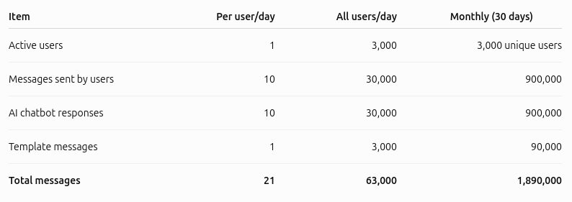
Important: Meta does not charge for incoming user messages. It charges for outgoing business messages, including AI responses and templates.

The current published rates for Kenyan recipients are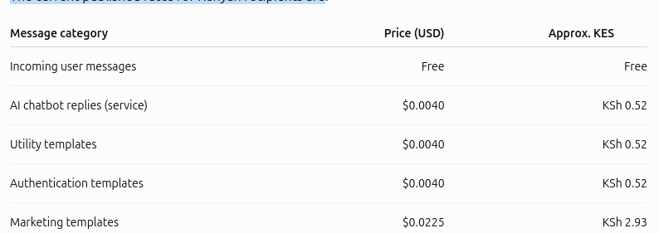

Daily WhatsApp API cost
Assuming the daily template is classified as a utility template, the calculation is
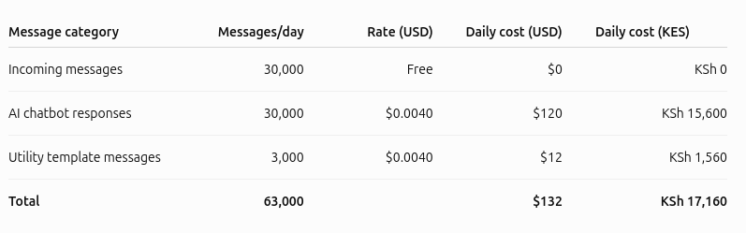

WhatsApp Cloud API: 24-Hour Customer Service Window and Exemptions (October 2026)
WhatsApp has a 24-hour customer service window and a separate 72-hour free-entry exemption. However, since 1 October 2026, opening the normal 24-hour window no longer automatically makes your AI chatbot responses free.
Meta's October 2026 pricing documentation indicates that eligible government and nonprofit organizations can continue receiving free service messages beyond the 1,000-message allowance through 31 December 2027. Eligibility must be confirmed by Meta.

